Keep Reading with Talking Books!
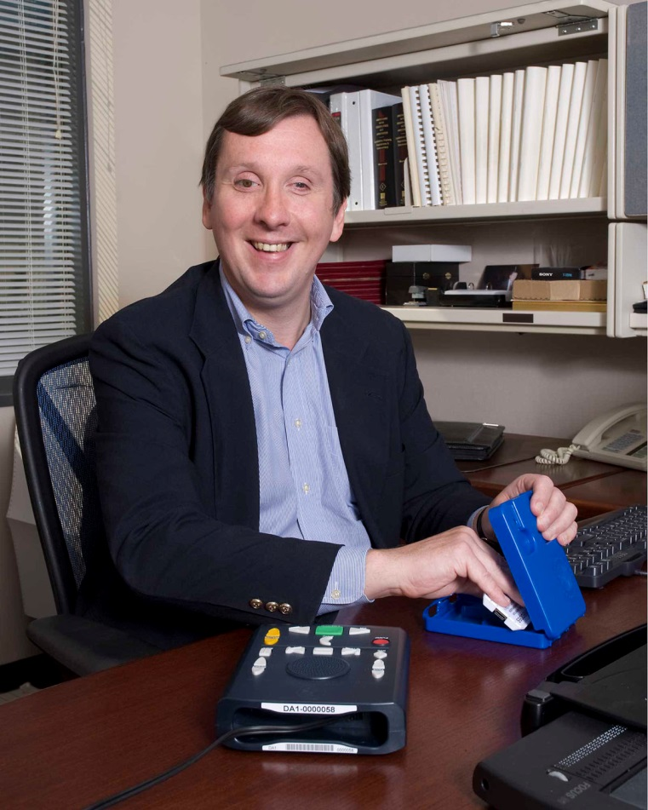
If you or someone you know has difficulty reading standard print, Talking Books may be the solution. Talking Books is a FREE program from the Library of Congress and the New York State Talking Book and Braille Library.
NYS Talking Book Library  (800) 342-3688  www.nysl.nysed.gov/tbbl | NYS Talking Book Library  (800) 342-3688  www.nysl.nysed.gov/tbbl | NYS Talking Book Library  (800) 342-3688  www.nysl.nysed.gov/tbbl | NYS Talking Book Library  (800) 342-3688  www.nysl.nysed.gov/tbbl | NYS Talking Book Library  (800) 342-3688  www.nysl.nysed.gov/tbbl | NYS Talking Book Library  (800) 342-3688  www.nysl.nysed.gov/tbbl | NYS Talking Book Library  (800) 342-3688  www.nysl.nysed.gov/tbbl | NYS Talking Book Library  (800) 342-3688  www.nysl.nysed.gov/tbbl | NYS Talking Book Library  (800) 342-3688  www.nysl.nysed.gov/tbbl

Tear off a tab and contact the New York State Talking Book and Braille Library today at (800) 342-3688 or go to www.nysl.nysed.gov/tbbl for more information.

